Automation Introduction Course

**Advantages**

*Improve the test´s efficiency

* Provide a border coverage

*Reduce total cost of testing

* Shorten the test execution period

*Increase the test frequency and reduce the required time for the test cycles

* More tests can be run per build and release

*The ability to create tests that cannot be done manually

*Tests are less subject to operator errors

**Disadvantages**

*Additional costs

*Harder to debuggear

*Programing knowledge are required

*Continued maintenance

You can´t automate everything

Limitations

Two factor authentication🡪 code that is send to personal device

ReCAPTCHA

Email

Automation based on test types

Functional and non functional

Functional

Unit

Integration

End to end

Iu

Non functional

Performace

Security

Regression

Smoke

**Framework types**

Capture playback

Linear Scripting

Structured Scripting

Module Based

Data driven

Keyword driven

Hybrid

Bdd- behavior driven development

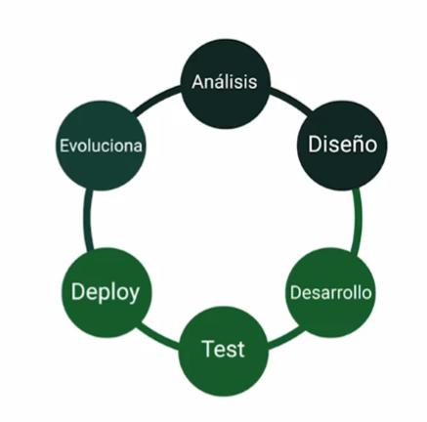

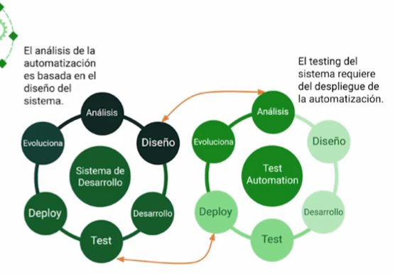

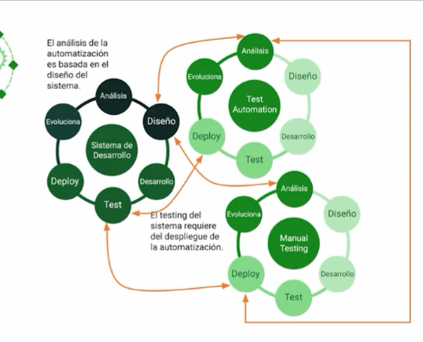

CI/CD continuos integration and continuos deployment

